# Get friend info

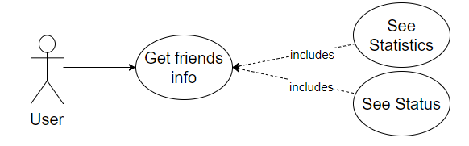

## Characteristic Information

|  |  |
| --- | --- |
| Goal: | The user can see different information about a friend. It can be divided in stats (friend current activity) and statistics (total messages sent, friends since, etc.). |
| Precondition: | The user have to have at least one friend in the friendlist. |
| Postcondition: | The user saw and know about a friend current information and his/her recent activity. |
| Involved User: | The user and one friend |
| Triggering Event: | When the user is curious about what his/her friend is doing right now.  When the user wonders and wants to see how well their friendship is going. |

This usecase has two subusecases, called “See Stats” and “See Statistics”

## GUIs for the standard uses

## Scenario for the standard use

| Step | User | Activity |
| --- | --- | --- |
| 1 | User | Log in |
| 2 | User | Look at the friendlist to see the friend’s current activity |
| 3 | User | Select a friend in the friendlist |
| 4 | User | Click the “Stats” button at the right top to show the stats |

## Scenarios for non-standard uses (bad cases or work around cases)

## GUIs for the non-standard uses

## Workflow

## Open Points

Unfriending

* If the user accidentally remove a friend and send a friend-request to him/her again, the previous information will be lost.

Spamming

* The user and the friend can fake the information with unnecessary messages in form of spamming.